TOWN OF BRUNSWICK WATER DEPARTMENT
LEAD SERVICE LINE REVIEW

The Town of Brunswick Water Department is reviewing the most likely residences to still have lead service lines in their home. Please take a moment to locate your water meter and determine if you have a copper service line into your home or if you may still have a lead service line coming through the wall or basement floor.

A copper service line will be approximately three quarters of an inch in diameter and have a dull brown or copper patina color.

A lead service line will be approximately an inch and half in diameter and will have a gray or pewter color. If you scratch this pipe with a knife or screw driver, it will have a silver look.

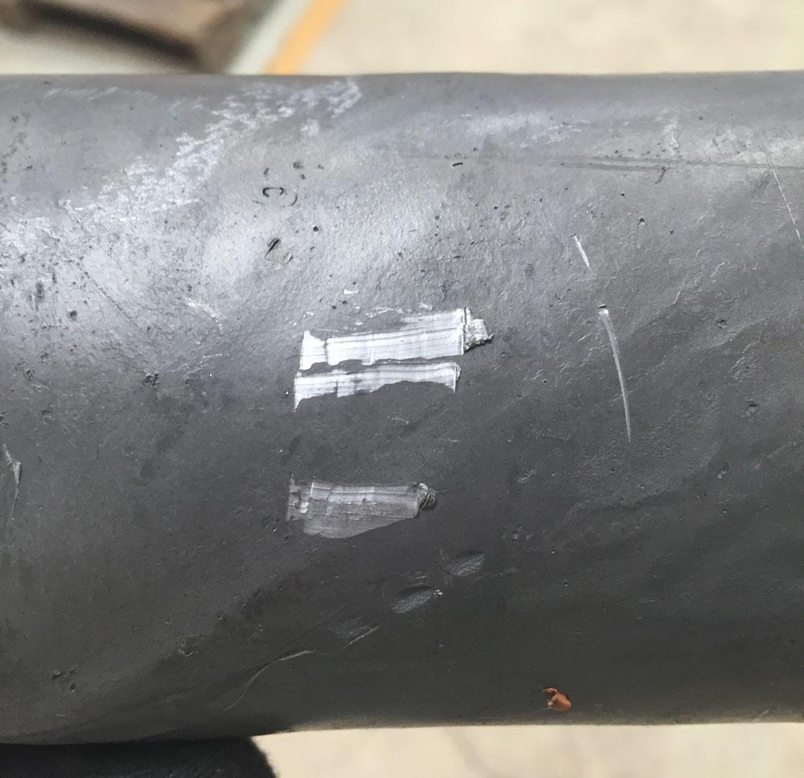 | 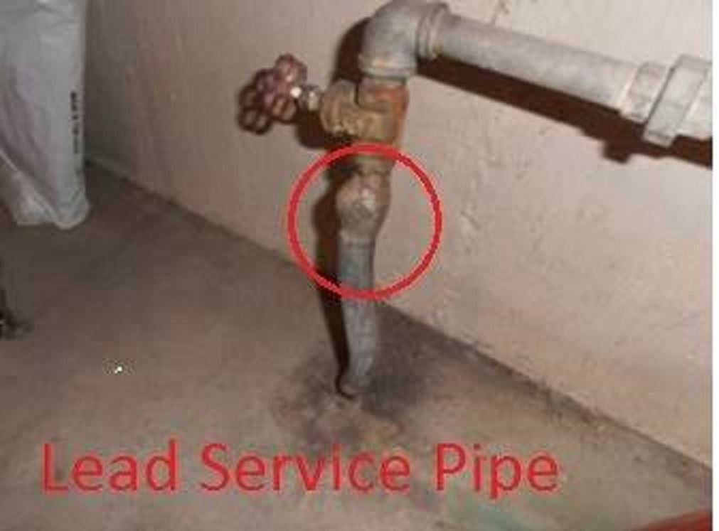

Please call the Water Department at 518 279-3461 ext. 114 and let us know if you have a lead service line. If you have a lead service line we will review your home to determine if additional lead water testing should be done. If you are not sure how to determine if you have a lead service line, the Water Department personnel will come out to your house to inspect.

Thank you for your cooperation.

William L. Bradley
Superintendent of Water

